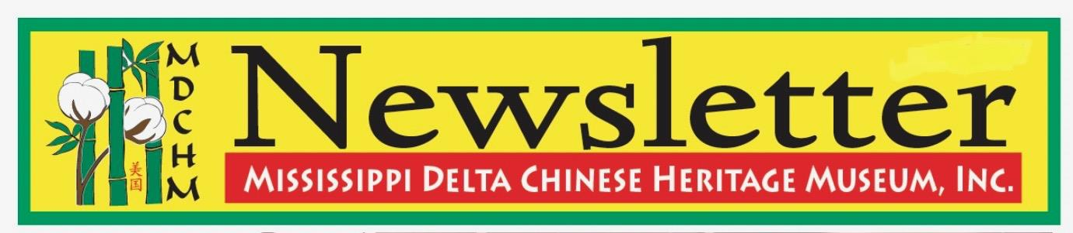
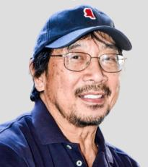
From the Editor: So much news and so much activity surrounding MDCHM will be brought to you with this edition. As you are aware, we are just weeks away from launching our third edition of “Inherited Legacy Series”. The invitation from President Gilroy Chow is reprinted here just as a reminder, or more importantly, an encouragement for you to attend. We members of the board of directors look forward to an exciting and rewarding weekend in September.
Also, news from the archives is brought to you from intern Ashley Jenkins, and we are delighted to include an article that Raymond Seid presents chronicling a basic commonality most of us have experienced from our past. A feature article that Carolyn Hong Chan has written presents the rise of Sam Chu Lin, a pioneer in radio and television broadcasting who rose to a national prominence. Board member, Cindi Quong Lofton, is spotlighted in this edition and she presents a very warm and heartfelt mini bio that could probably stand alone as a feature article in itself. So, I am glad to bring to you “The News from MDCHM”, and we look forward to seeing you in September. 8.14.2024 Harry Gong

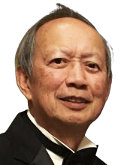
From the desk of the President - It is with excitement that I’m proud to announce the resumption of the MDCHM Inherited Legacies Series, honoring notable Chinese people from the Mississippi Delta. These are folks that have gone on to make significant contributions in various fields across the country. On September 9th, 2023, we are honoring Margaret Chow Starner. Margaret has been recognized by many financial publications (Fortune, WSJ, Forbes, etc.) as a top Wealth Advisor in the country for the past 15+ years. She credits her beginnings in the family grocery store in Shelby, Mississippi to much of her success. Please come and hear from her as our speaker for the evening.
We are also having the HT CHEN Dance Company from New York City perform excerpts from South of Gold Mountain on the campus of Delta State University that morning. We are in the process of an extensive upgrading of the exhibits on the third floor of the archives and will be re-opened this Fall. The Legacy Wall is also being updated to reflect the generosity of so many folks in the past years. Also, the first floor is being renovated to improve visitor and staff convenience. Come and see the changes! The Grammy Museum is offering Asian Family Day, September 10th, with free admission to the Museum and a screening of Far East Deep South. Baldwin Chiu, Larrisa Lam and daughter Caliya will be hosting and performing as well. We will be serving brunch prior to the morning dance performance and a Delta buffet dinner prior to the Saturday evening program. Please register early as we will be limited to the number of participants for the day. Please send your checks to the address listed as we are NOT equipped for electronic payments. All are welcome to enjoy these events for the entire day simply with the paid registration of each individual attending. Reserve your place NOW.
NEWS FROM THE ARCHIVES
Ashley Jenkins
National Mahjong Day†
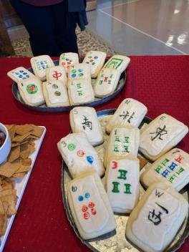
National Mahjong Day was on April 30, 2023. Ashley Jenkins hosted a game day event at the DSU Archives and Museum that was sponsored by the Mississippi Delta Chinese Heritage Museum. There were snacks and prizes to go along with all of the fun and games. We had twenty-one guests join the festivities. Most of them were from the Wednesday group who play in the archives but there were some from Jackson, MS, Clarksdale, MS, Greenville, MS, and Memphis, TN. The Archive Gallery was decorated in gold and red decorations with inspirational Mandarin quotes of luck. The first person at each table to mahjong received a prize, so the competition was intense. Ashley taught American Mahjong to eight of the guests in the seminar room. The best way to learn is to play, so eventually everyone got their hands on the tiles. †

American Queen
The American Queen Voyages started this spring semester in early February. There were twelve boats scheduled for the spring with each boat at full capacity. We enjoyed meeting the guests who came to the museum. We met people from all over the world including sixteen different countries and thirty-five states. This semester we had eleven new countries visit the museum. The total number of guests for the spring was 510 guests. They were engaging and wanting to learn more about Delta Chinese. They ask questions and want further readings. This has influenced the new renovations and the flow of the
museum. We want to thank all of the volunteers who help out with the boat groups. If you do have an opportunity to volunteer during a boat day, please stop by the museum. We look forward to the river boats next semester which will come back in August 2023. †

HONORING SAM CHU LIN
Pioneer Chinese American Broadcast Journalist
MARCH 3, 1939 – MARCH 5, 2006
“Choose your roots for a positive Purpose”
MDCHM is pursuing the placement of a historical marker in Greenville, Mississippi to honor the legacy of Sam Chu Lin, pioneer American broadcast and print journalist. The effort is supported by Sam’s widow, Judy Chu Lin, and a generous donation by Dickson Joe, son of Joe Ting, who was a partner in the iconic Joe Gow Nue Co. on Washington Avenue in Greenville.
Sam Chu Lin was born in Greenwood, Miss. to George and Frances Chu Lin on March 3, 1939. Sam began his lengthy career as Sammy Lin at Greenville’s radio station WJPR on S. Poplar Street while he was attending Greenville High School. A request has been made to the owner of the property for permission to place the marker at this site. A leader of the marker committee at the Mississippi History and Archives Department is encouraging recognition of Sam, the only Chinese American from the state listed on Wikipedia as a prominent Chinese American.
One of the first Asian American broadcast and print journalists to work for major television networks, Sam was the first CBS reporter to broadcast the fall of Saigon and the end of the Vietnam war on April 30, 1975. In 1989 he reported the Beijing Tiananmen Square protest. He fought the early battle to produce and broadcast documentaries about the Asian American experience of struggle for civil rights, equal housing, and fair employment practices.
While I was national communications director for the Chinese American Citizens Alliance (C.A.C.A.), Sam contacted me to help him with New Mexico contacts for his 1999 coverage of the Wen Ho Lee case in New Mexico, which focused on government stereotyping of Chinese Americans as spies for China. His story on Asian Civil War veterans motivated C.A.C.A. to work with Rep. Mike Honda (D-CA) to pass H. Res. 415 to recognize their service. This legislative achievement ultimately led to bills apologizing for the Chinese Exclusion Acts and the Congressional Gold Medal Act for Chinese American World War II Veterans.
Sam wrote a story in 1975 of the destitute plight of DC Comics Superman creators, Joe Shuster and Jerry Siegel, who sold their copyrights for $130 and never were paid any royalties. Warner Brothers followed with a contract to provide a pension and royalties. Sam’s stories laid the groundwork for increased civic engagement and production of documentaries and news stories recognizing the history and contributions of the Asian American community.
I had the privilege of presenting Sam the 2005 Spirit of America award at the national convention of the Chinese American Citizens Alliance convention in Salinas. The award is the organization’s most prestigious award in recognition of a lifetime of dedicated service and nationally impactful leadership. Many of Sam’s friends from across the country with Mississippi roots were present to celebrate the occasion.
Sam used the mantra “Choose Your Roots for a Positive Purpose” to guide his life. Passionate, empathetic and persistent, he used his authoritative baritone voice and terse writing skill to inform, motivate and empower Americans to positive action.
Sam, who unexpectedly died on March 6, 2006, was widely mourned with glowing tributes from his fellow national journalists and broadcasters for his talent and pioneering contributions. Gone too soon at age 67, his legacy lives on with those who “choose [their] roots for a positive purpose.”
____________________________________________________________
Additional Footnote
Joe Shuster and Jerry Siegel (Dec. 23, 1975 broadcast available from the Vanderbilt News Archive Superman Creators #238294
From Wikipedia https://en.wikipedia.org/wiki/Sam_Chu_Lin
“During his lifetime, Chu Lin won various awards for his reporting and community service, and produced stories on the history of Asians in the U.S. for ABC and NBC. His television documentary, Chu Lin Is an Old American Name, which told the story of
the Chinese American experience through one family's experiences, won a National Headliner Award from the Press Club of Atlantic City in New Jersey.
Other awards include: the Golden Mike Award; Community Achievement Award from the Los Angeles chapter of the Organization of Chinese Americans; Lifetime Achievement Award from the Asian American Journalists Association; 2005, Spirit of America Award, Chinese American Citizens Alliance; 2006, Asian Legacy Award from Asian Business Association.
He also won numerous awards from the Associated Press, United Press International, the Press Club of Los Angeles, and the Radio and Television News Association.”
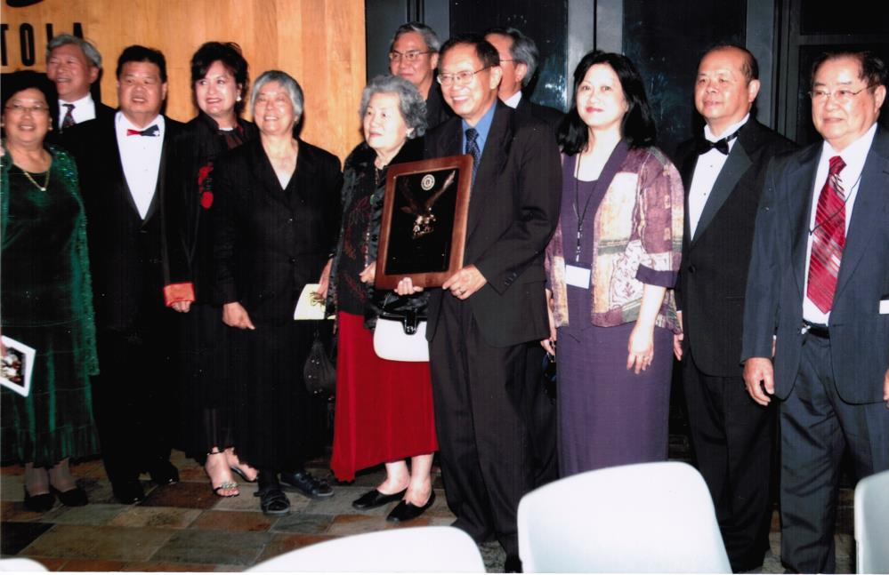
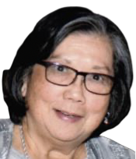
Carolyn Hong Chan
MDCHM Director,
Former National President, C.A.C.A.

Sam Chu Lin receiving the Spirit of America Award with Carolyn and other dignitaries 2005]

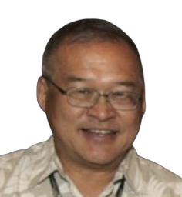
Another contribution from Raymond Seid
"Preservation of Our Delta Legacy through Photographic Journals" by Raymond Seid
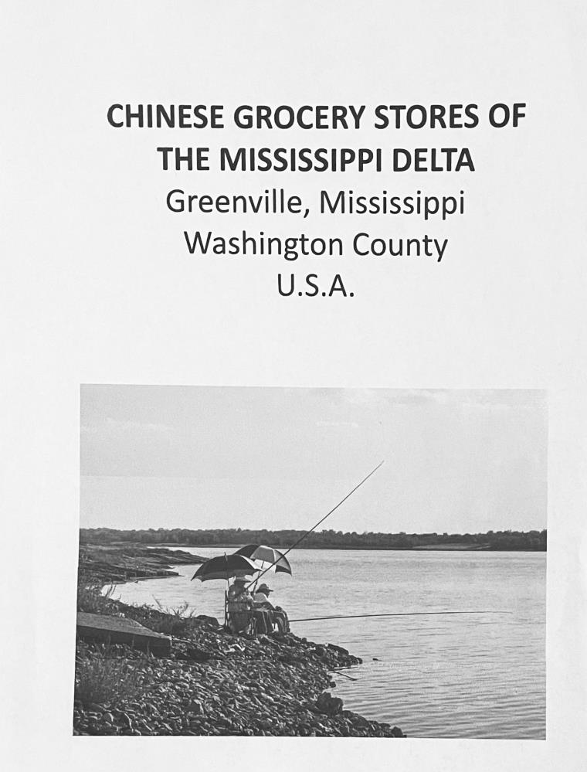
Photography as a hobby has been my passing interest since high school. I became an accidental photographer of things Chinese but strictly a hobby. Totally on a whim I began developing an interest in snapping pictures of Chinese grocery stores in my hometown Greenville, Mississippi. Perhaps this was when I first develop my Chinese identity......and with that, the thought of preserving the images of Chinese grocery stores became a genesis of how best to selectively share some of my photos with others.
All the while I had to be true to myself that at this late date the opportunity to capture many of the Chinese grocery stores in my hometown is already long gone, forever.......I was decades too late......yet better late than never. I've shared a few of my photos on Facebook social sites, especially on the Mississippi Delta Chinese R Us website. However, having become a Board member of the Mississippi Delta Chinese Heritage Museum in Cleveland, Mississippi, I have broadened my perspective on how to support telling the Mississippi Delta Chinese story. I had a good idea of what outreach materials were made available to the public at the Museum......and with that in mind, how to supplement the publicity of the Delta Chinese were excitedly brewing for months in my mind.
After some deliberation the idea of an educational photo booklet was born. A dozen photos of Chinese grocery stores had to be selected from my limited personal collection. Permission from the owners of two of the selected photos had to be procured for use of their photos. I also enhanced all photos with Adobe Photoshop Lightroom program.......then used Adobe PowerPoint to format and finalize each page of the booklet which additionally included a short introduction of the Chinese in Greenville and a listing of 50 Chinese grocery stores in its heydays.
The booklets are donated to the Museum with hopes that visitors to the Museum will grow to understand and appreciate the legacy of the Delta Chinese. Additionally, I hope it will inspire my fellow Chinese in the Cleveland, Clarksdale, Greenwood and other Chinese enclaves to develop their own booklets to share their grocery stories.

Spotlighting Cindi Quong Lofton
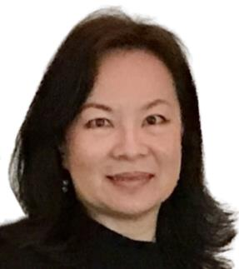
Born & raised in the Mississippi Delta, Cindi’s first job, like many Delta Chinese Children was working in the family grocery store, “Leadway” in Shaw, MS. Her Father, Alfred Quong a native of Glen Alan, MS and Mother, May Jew Quong, from Alameda, CA overcame incredible obstacles to establish the business that would eventually provide their two daughters education and opportunities far beyond the borders of the check-stand. They were successful: After graduating Bayou Academy, Linda went to Yale, while Cindi obtained a BA in Psychology and a Master of Education from Delta State University, partially in a “search for self” in the Sea of Black and White Faces in the Delta. Her parent’s sacrifices allowed her to enjoy careers in Banking, Education and Big Pharma.
Sadly, the hopeful beginnings and hard-won success came to a tragic end with the murders of Mr. Quong and family friend SoHa Jung as they stood at the check stand. Devastated, but unwilling to give in to fear and hate; Cindi knew her response had to honor her Father and the multitude of Asian store owners who lost their lives in similar ways. She vowed not to be a silent by-stander, but to do some good in the world and to combat Asian stereotyping so people like her father would be seen as Individuals.
She became a Licensed Professional Counselor to be a compassionate but vital force. Along the way she was fortunate enough to work with the MDCHM, where she found home at last, in the Sea of stories of other Mississippi Delta Chinese. Today she is Executive Director of Community Counseling Center, a non-profit organization, where she works with Individuals affected by all types of grief and loss, even working with some offenders. Cindi has Faith that her purpose is to provide solace to people in pain, while also diffusing stereotypical thinking about Asians. She’s grateful and humbled to be a part of MDCHM, where visitors of all races learn of the history, hard work and contributions of the Mississippi Delta Chinese and take their new-found knowledge to others, making the world a smaller and more understanding place. Mrs. Quong, Cindi and husband, Danny reside and worship in Shaw, with faith, hope and peace.

